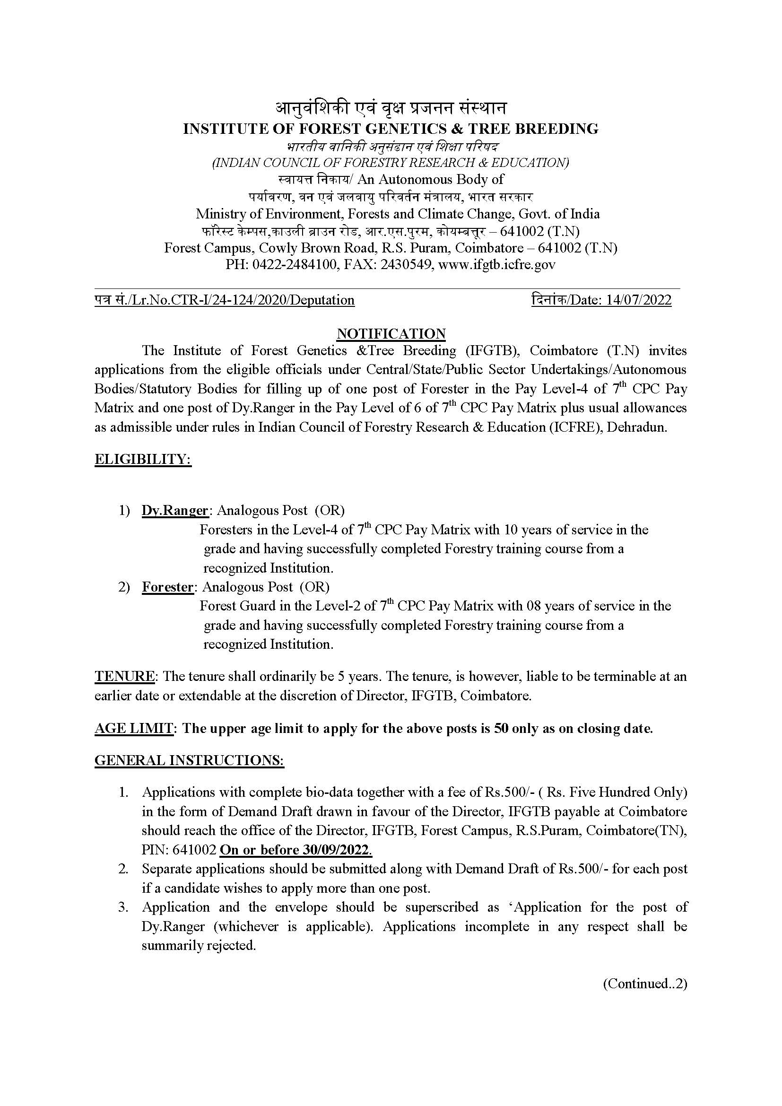

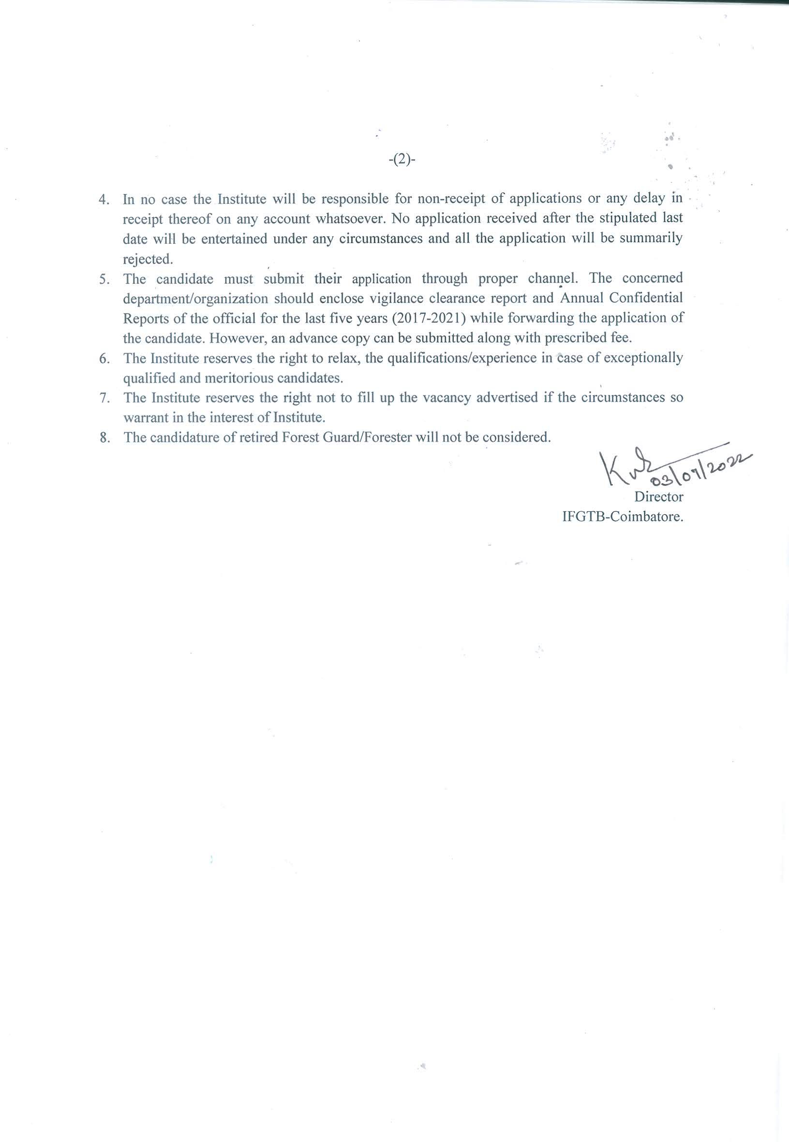

**PROFORMA FOR APPLICATION FOR THE POST OF FORESTER**

1. Name (in Block Letter) :
2. Date of appointment to the present post :
3. Post currently held with pay scale :
4. Date of Birth ( in Christian era) :
5. Father’s/Husband’s Name :

# Address for correspondence :

( in block letters with pin code)

1. Contact Number :
2. E-mail ID :
3. Educational Qualifications :
4. Details of past service ( chronologically from present position backwards)

|  |  |  |  |  |
| --- | --- | --- | --- | --- |
| State | Forest Division | Post held  (with pay scale) |  | |
| From | To |
|  |  |  |  |  |
|  |  |  |  |  |
|  |  |  |  |  |
|  |  |  |  |  |
|  |  |  |  |  |

1. Details of professional training course :

(Attached copy of Certificate)

1. Date of retirement under the rules of

Central/State Government :

1. Any other information :
2. Bank Draft No. with date and amount:

Place: (Signature of the candidate)

Date:

**PROFORMA FOR APPLICATION FOR THE POST OF DEPUTY RANGER**

1. Name (in Block Letter) :
2. Date of appointment to the present post :
3. Post currently held with pay scale :
4. Date of Birth ( in Christian era) :
5. Father’s/Husband’s Name :
6. Address for correspondence :

( in block letters with pin code)

1. Contact Number :
2. E-mail ID :
3. Educational Qualifications :
4. Details of past service ( chronologically from present position backwards)

|  |  |  |  |  |
| --- | --- | --- | --- | --- |
| State | Forest Division | Post held  (with pay scale) |  | |
| From | To |
|  |  |  |  |  |
|  |  |  |  |  |
|  |  |  |  |  |
|  |  |  |  |  |
|  |  |  |  |  |

1. Details of professional training course :

(Attached copy of Certificate)

1. Date of retirement under the rules of

Central/State Government :

1. Any other information :
2. Bank Draft No. with date and amount:

Place: (Signature of the candidate)

Date:

**Annexure**

Certificate to be furnished by the Employer / Forwarding Authority certified that :

1. The particulars furnished by Shri/Smt. ______________________________ are correct.
2. There is no vigilance / disciplinary case either pending or contemplated against him/her.
3. Integrity of the applicant is certified.
4. Photocopies of the up-to-date ACRs, attested by an officer not below the rank of an Under Secretary to the Govt. of India are enclosed.

Date : (Signature of the Head of the Department /

Forwarding Authority)

Department/Office with seal

Telephone No._________________